Project Design Phase-II
Data Flow Diagram & User Stories
Date | 26-09-2026
Team ID | SWTID-2026-2737
Project Name | AI WeatherWise API
Maximum Marks | 4 Marks

Data Flow Diagrams:
A Data Flow Diagram (DFD) represents the flow of weather information within the AI WeatherWise API system. It shows how weather data enters the system, gets processed, and is returned to the user.
EXAMPLE:
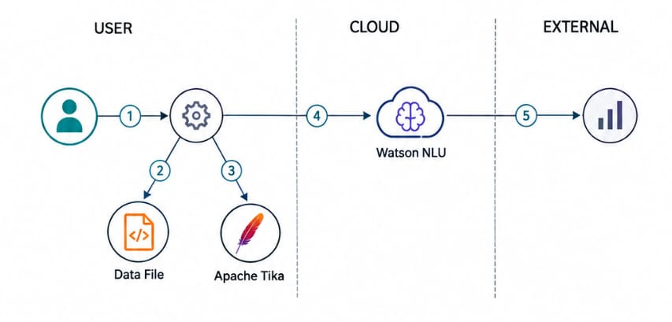

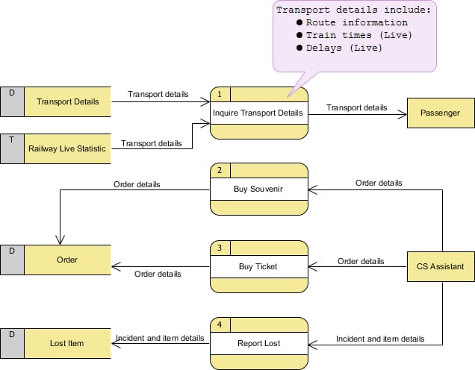
User Stories
Use the below template to list all the user stories for the product.
User Type | Functional Requirement (Epic) | User Story Number | User Story/Task | Acceptance criteria | Priority | Release
Customer (Mobile user) | Registration | USN-1 | As a user, I can register for the application by entering my email, password, and confirming my password. | I can access my account / dashboard | High | Sprint-1
Customer (Mobile user) | Registration | USN-2 | As a user, I will receive confirmation email once I have registered for the application | I can receive confirmation email & click confirm | High | Sprint-1
Customer (Mobile user) | Registration | USN-3 | As a user, I can register for the application through Facebook | I can register & access the dashboard with Facebook Login | Low | Sprint-2
Customer (Mobile user) | Registration | USN-4 | As a user, I can register for the application through Gmail | I can register & access the dashboard with Google/Gmail Login | Medium | Sprint-1
Customer (Mobile user) | Login | USN-5 | As a user, I can log into the application by entering email & password | I can successfully authenticate and view my dashboard | High | Sprint-1
Customer (Mobile user) | Dashboard | USN-6 | As a user, I want to view my profile details and recent activity on the dashboard | Dashboard loads all user details and activity correctly | High | Sprint-2
Customer (Web user) | Browsing & Search | USN-7 | As a web user, I want to search and filter items on the web portal | Search results match criteria accurately | High | Sprint-1
Customer Care Executive | Support Tickets | USN-8 | As a customer care executive, I can view, update, and resolve user support tickets | Ticket status updates to resolved and user is notified | High | Sprint-2
Administrator | User Management | USN-9 | As an administrator, I can view, block, or delete user accounts | Admin panel reflects modified user account status | Medium | Sprint-2

